PROJECT REPORT



Password security system

**Submitted By:**

Javeria Riaz 2016-CS-251

Khadija Zahoor 2016-CS-259

**Submitted To:**

Asim Rehmat

**DEPARTMENT OF COMPUTER SCIENCE AND ENGINEERING**

UNIVERSITY OF ENGINEERING AND TECHNOLOGY, LAHORE

**CONTENTS**

1. Abstract
2. Introduction
   1. Requirement
      1. Description
3. Methodology
4. Design
   1. Circuit components
   2. Schematic Diagram
   3. Theory of Operation
   4. Expected Output
5. Implementation
6. Testing
7. Applications
8. Conclusion
9. **Abstract**

The password security system using NOR and XOR gates, resisters, diodes and two four way dip switches is used to protect any sort of thing you want. One switch acts to hold the correct code for unlocking the lock, while the other switch serve as a data entry point for the person trying to open the lock. It can be accessed if and only if the entered code matches with your password. This is very useful for security purposes.

**2. INTRODUCTION**

The password security system uses 8 bit DIP switches one is used to store the password and other is use to take the input from the user. If both of these matches then the green LED will glow otherwise red LED will glow.

* 1. **REQUIREMENTS**

The password security system requires the following things to be done for its completion.

**2.1.1** **DESCRIPTION**

This security system uses a NOR and XOR gates. This project also uses DIP switches and resistors and switching diodes. To understand this first of all we need to understand the working of the NOR and XOR gates respectively. Their truth tables are shown as follows.

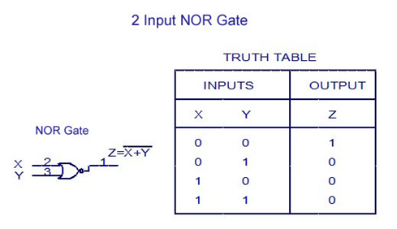

Figure 1: Truth table of NOR gate

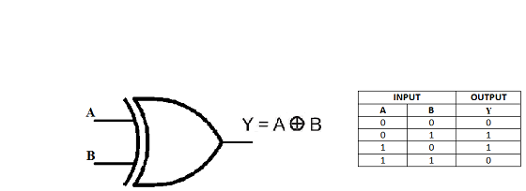 Similarly here is the truth table for the XOR gate in fig 2.

Figure 2: Truth table of XOR gate

This experiment may be built using only one 8-position DIP switch, but the concept is easier to understand if two switch assemblies are used. The idea is, one switch acts to hold the correct code for unlocking the lock, while the other switch serves as a data entry point for the person trying to open the lock. In real life, of course, the switch assembly with the “key” code set on it must be hidden from the sight of the person opening the lock, which means it must be physically located *elsewhere* from where the data entry switch assembly is. This requires two switch assemblies. However, if you understand this concept clearly, you may build a working circuit with only one 8-position switch, using the left four switches for data entry and the right four switches to hold the “key” code.

For extra effect, choose different colors of LED: green for “Go” and red for “No go.

**3. METHODOLOGY**

The circuit consists of 12 resistors of 470K ohm each connected to one of the DIP switches. Each switch is also connected to the XOR gates whose outputs are attached to the 4 switching diodes. The switching diodes are attached to NOR gate’s inputs and the second input is grounded. The output of these NOR gates are connected to the LEDs. These LEDs will glow telling us whether the password is correct or not.

This circuit illustrates the use of [XOR (Exclusive-OR)](https://www.allaboutcircuits.com/textbook/digital/chpt-3/multiple-input-gates/) gates as bit [comparators](https://www.allaboutcircuits.com/textbook/experiments/chpt-6/voltage-comparator/). Four of these XOR gates compare the respective bits of two 4-bit binary numbers, each number “entered” into the circuit via a set of switches. If the two numbers match, bit for bit, the green “Go” LED will light up when the “Enter” Push button switch is pressed. If the two numbers do not exactly match, the red “No go” LED will light up when the “Enter” pushbutton is pressed. Connected to the common sides of the diodes will provide a “low” signal state to the NOR logic.

Because four bits provides a mere sixteen possible combinations, this lock circuit is not very sophisticated. If it were used in a real application such as a home security system, the “No go” output would have to be connected to some kind of siren or other alarming device so that the entry of an incorrect code would deter an unauthorized person from attempting another code entry. Otherwise, it would not take much time to try all combinations (0000 through 1111) until the correct one was found! In this experiment, I do not describe how to work this circuit into a real security system or lock mechanism, but only how to make it recognize a pre-entered code.

The “key” code that must be matched at the data entry switch array should be hidden from view, of course. If this were part of a real security system, the data entry switch assembly would be located *outside* the door and the key code switch assembly *behind* the door with the rest of the circuitry. In this experiment, you will likely locate the two switch assemblies on two different breadboards, but it is entirely possible to build the circuit using just a single (8-position) DIP switch assembly. Again, the purpose of the experiment is not to make a real security system, but merely to introduce you to the principle of XOR gate code comparison.

It is the nature of an XOR gate to output a “high” (1) signal if the input signals are *not* the same logic state. The four XOR gates’ output terminals are connected through a diode network which functions as a four-input OR gate: if *any* of the four XOR gates outputs a “high” signal—indicating that the entered code and the key code are not identical—then a “high” signal will be passed on to the [NOR gate logic](https://www.allaboutcircuits.com/textbook/digital/chpt-3/ttl-nor-and-or-gates/" \t "_blank). If the two 4-bit codes are identical, then none of the XOR gate outputs will be “high,” and the pull-down resistor

The NOR gate logic performs a simple task: prevent either of the LEDs from turning on if the “Enter” pushbutton is not pressed. Only when this pushbutton is pressed can either of the LEDs energize. If the Enter switch is pressed and the XOR outputs are all “low,” the “Go” LED will light up, indicating that the correct code has been entered. If the Enter switch is pressed and any of the XOR outputs are “high,” the “No go” LED will light up, indicating that an incorrect code has been entered. Again, if this were a real security system, it would be wise to have the “No go” output do something that deters an unauthorized person from discovering the correct code by trial-and-error. In other words, there should be some sort of *penalty* for entering an incorrect code Here is the sample circuit of password security system on Bread board

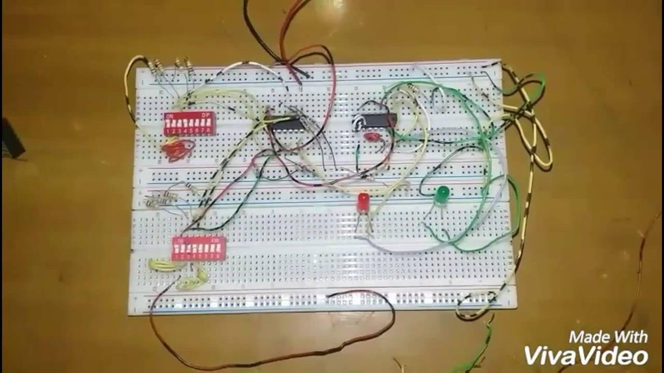

Figure 3: Sample Circuit on Bread board

1. **DESIGN**

**4.1 CIRCUIT COMPONENTS**

The password security system requires the following components in its design.

* IC
  1. 4001 quad NOR Gate – 1
  2. 7486 quad XOR Gate-1
* Diodes and switches
  1. 1N914 Switching Diodes– 4
  2. Pushbutton switch, normally open-1
  3. Four position DIP switches-2
* Resistors
  1. 470k ohm– 12
* Miscellaneous
  1. Battery 9V-1
  2. LED-2
  3. Breadboard-2

Here is the description of each component:

**NOR Gate:**

The **NOR gate** is a digital [logic gate](https://en.wikipedia.org/wiki/Logic_gate) that implements [logical NOR](https://en.wikipedia.org/wiki/Logical_NOR) - it behaves according to the truth table to the right. A HIGH output (1) results if both the inputs to the gate are LOW (0); if one or both input is HIGH (1), a LOW output (0) results. NOR is the result of the [negation](https://en.wikipedia.org/wiki/Negation) of the [OR](https://en.wikipedia.org/wiki/OR_gate) operator. It can also be seen as an AND gate with all the inputs inverted. NOR is a [functionally complete](https://en.wikipedia.org/wiki/Functionally_complete) operation—NOR gates can be combined to generate any other logical function. It shares this property with the [NAND gate](https://en.wikipedia.org/wiki/NAND_gate). By contrast, the [OR](https://en.wikipedia.org/wiki/Logical_disjunction) operator is *monotonic* as it can only change LOW to HIGH but not vice versa.



Figure 4: Symbol of NOR gate

The truth table of NOR gate is such that the invert of OR because of the presence of the NOT gate at the end of the OR gate. Following is the truth table:

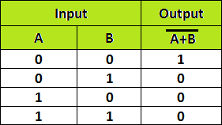

Figure 5: Truth table of NOR gate

**XOR Gate:**

The **XOR gate** (sometimes **EOR gate**, or **EXOR gate** and pronounced as **Exclusive OR gate**) is a digital [logic gate](https://en.wikipedia.org/wiki/Logic_gate) that gives a true (1/HIGH) output when the number of true inputs is odd. An XOR gate implements an [exclusive or](https://en.wikipedia.org/wiki/Exclusive_or); that is, a true output results if one, and only one, of the inputs to the gate is true. If both inputs are false (0/LOW) and both are true, a false output results. XOR represents the inequality function, i.e., the output is true if the inputs are not alike otherwise the output is false. A way to remember XOR is "one or the other but not both".

XOR can also be viewed as addition modulo 2. As a result, XOR gates are used to implement binary addition in computers. A [half adder](https://en.wikipedia.org/wiki/Adder_(electronics)#half_adder) consists of an XOR gate and an [AND gate](https://en.wikipedia.org/wiki/AND_gate). Other uses include subtractors, comparators, and controlled inverters.

****

Figure 6: Symbol of XOR gate

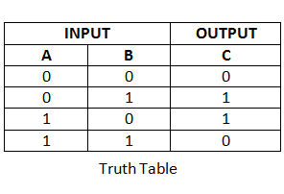Similarly thee truth table for the XOR Gate can also be seen which shows that the output is zero when the inputs are same.

Figure 7: Truth table of XOR gate

**SWITCHING DIODES:**

Switching diodes are a single p-n diode in a discrete package. A switching diode provides the same functionality as a switch. It has high resistance below the specified applied voltage similar to an open switch, whereas above that voltage it changes in a sudden way to the low resistance of a closed switch. Switching diodes are used in devices such as ring modulation.

**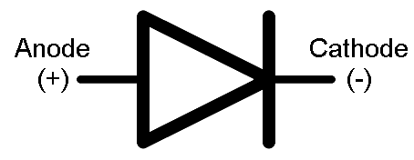**

Figure 8: Symbol of Diodes

There are many different kinds of switching diodes. At Future Electronics we stock many of the most common types categorized by power dissipation, maximum reverse recovery time, maximum reverse voltage, maximum average forward current, packaging type and maximum peak current. The parametric filters on our website can help refine your search results depending on the required specifications.

**FOUR POSITION DIP SWITCHES:**

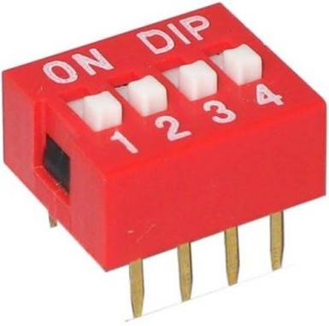A **DIP switch** is a manual [**electric switch**](https://en.wikipedia.org/wiki/Electric_switch)that is packaged with others in a group in a standard [dual in-line package](https://en.wikipedia.org/wiki/Dual_in-line_package) (DIP). The term may refer to each individual switch, or to the unit as a whole. This type of switch is designed to be used on a [printed circuit board](https://en.wikipedia.org/wiki/Printed_circuit_board) along with other [electronic](https://en.wikipedia.org/wiki/Electronics) components and is commonly used to customize the behavior of an electronic device for specific situations. DIP switches are an alternative to [jumper](https://en.wikipedia.org/wiki/Jumper_(computing)) blocks. Their main advantages are that they are quicker to change and there are no parts to lose.

Figure 9: Four position Dip Switch

**RESISTORS:**

A **resistor** is a [passive](https://en.wikipedia.org/wiki/Passivity_(engineering)) [two-terminal](https://en.wikipedia.org/wiki/Terminal_(electronics)) [electrical component](https://en.wikipedia.org/wiki/Electronic_component) that implements [electrical resistance](https://en.wikipedia.org/wiki/Electrical_resistance) as a circuit element. In electronic circuits, resistors are used to reduce current flow, adjust signal levels, to divide voltages, [bias](https://en.wikipedia.org/wiki/Biasing) active elements, and terminate [transmission lines](https://en.wikipedia.org/wiki/Transmission_line), among other uses. High-power resistors that can dissipate many [watts](https://en.wikipedia.org/wiki/Watt) of electrical power as heat may be used as part of motor controls, in power distribution systems, or as test loads for [generators](https://en.wikipedia.org/wiki/Electric_generator). Fixed resistors have resistances that only change slightly with temperature, time or operating voltage. Variable resistors can be used to adjust circuit elements (such as a volume control or a lamp dimmer), or as sensing devices for heat, light, humidity, force, or chemical activity.

**4.2 SCHEMETIC DIAGRAM:**

Following is the schematic diagram of password security system on Multisim.

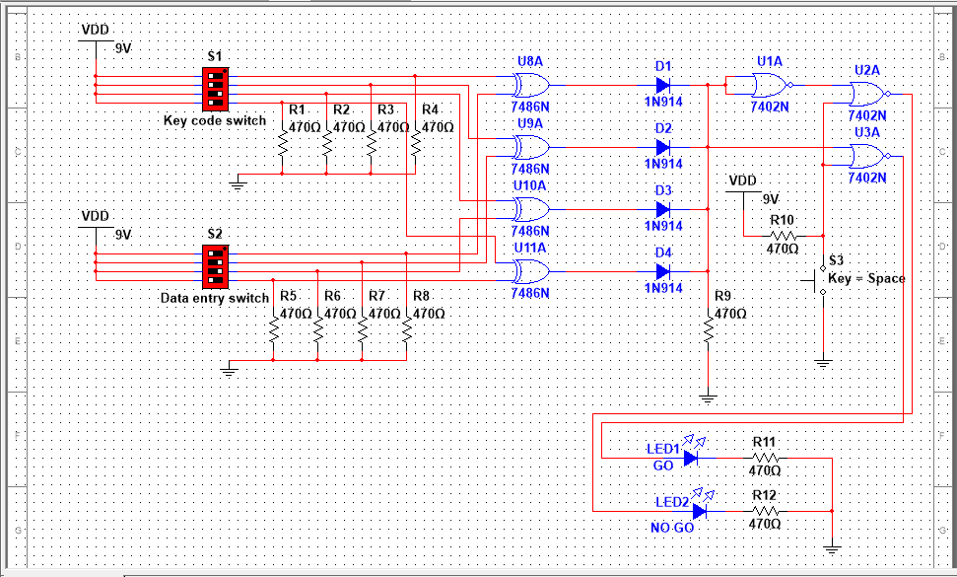

Figure 10: Schematic Diagram on Multisim

Here the circuit diagram is made on Multisim which shows all the connection that must be made accordingly to make a password security system.

Moreover it is to be noted the all the necessary connections are shown in this case. Which are connected to the LEDs that show that which green LED will glow whenever the password is correct and red will glow is the password is incorrect.

**4.3 THEORY OF OPERATION:**

First of all connect each terminal of the DIP switch to the Vdd. Connect other terminals of both the DIP switches to the 10k ohm resistors and then connect one terminal of the input DIP switch and one terminal of Key code DIP switch with two of the inputs of the XOR gates respectively. All the four terminals of the all the XOR gates are connected to the Diodes. These are then connected to the NOR gates. One of the output of the NOR gate is connected to the red LED and the other is connected to the green LED.

**4.4 EXPECTED OUTPUT:**

We will enter a password in the DIP switch key code. Now, if the input password matches with the password of the key code the green LED will glow and if it does not matches then the red LED will glow.

1. **IMPLEMENTATION:**

After the implementation of the Password Security System circuit on the breadboard. The circuit look like this:

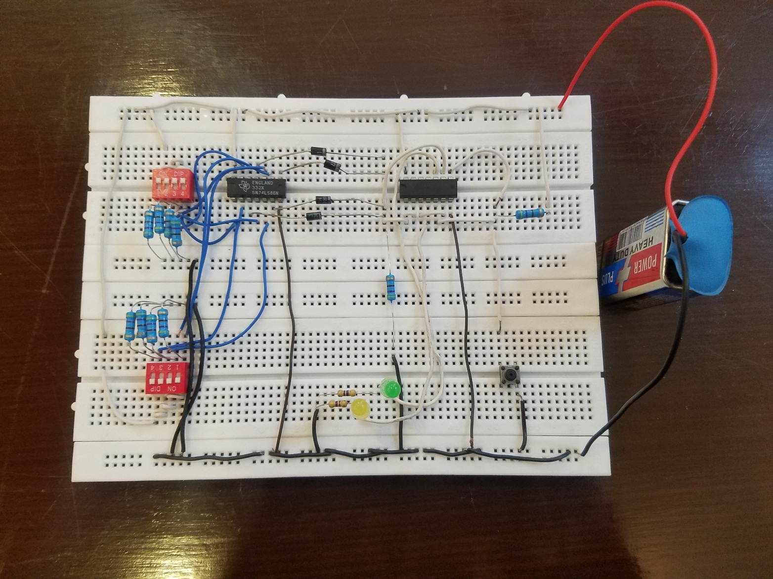

Figure 11: Circuit on Bread board

1. **TESTING**

|  |  |  |
| --- | --- | --- |
|  |  |  |
|  |  |  |

This is the result that we got after testing of the password security system.

With same password on both switches green LED glow because correct password is entered and it is GO condition and when there is different password on both switches red LED glow because incorrect password is entered and it is NO GO condition

1. **APPLICATIONS**

Applications of this circuit includes use in the areas where security is needed. For example banks, offices, organizations, homes and companies etc. This system is password based and allows only authorized person to access it with a password and is very important to prevent theft.

1. **CONCLUSION**

The IC’s were tested and results found were exactly similar to the required results. It was concluded that we have learnt the following things:

* To patch the circuit containing different logic gates.
* Using XOR gates as bit comparators.
* How to build simple gate functions with diodes and a pull-up/down resistor.
* Using NOR gates as controlled inverters.

**REFRENCES**

[1]<https://www.allaboutcircuits.com/textbook/experiments/chpt-7/simple-combination-lock/>

[2] https://www.youtube.com/watch?v=I0V5qzVDHOM

The above is the project proposal which shows what the requirements to make this project are.